**COVID TEST**

**&**

**VACCINATION SYSTEM**

**PROJECT GROUP MEMBER**

|  |  |
| --- | --- |
| **Students Id** | **Students Name** |
| ***Student1449388*** | ***Muhammad Ahsan*** |
| ***Student1449717*** | ***Muhammad Mohsin Mukhtiar*** |
| ***Student1444862*** | ***Fareeha*** |
| ***Student1429148*** | ***Marfia Rani*** |

**CURRICULUM BATCH**

**7062 2301B2**

**FACULTY**

**SIR HARIS NASEER**

**CO-ORDINATOR**

**MISS MAHA**

**ACCOUNT REGISTER**

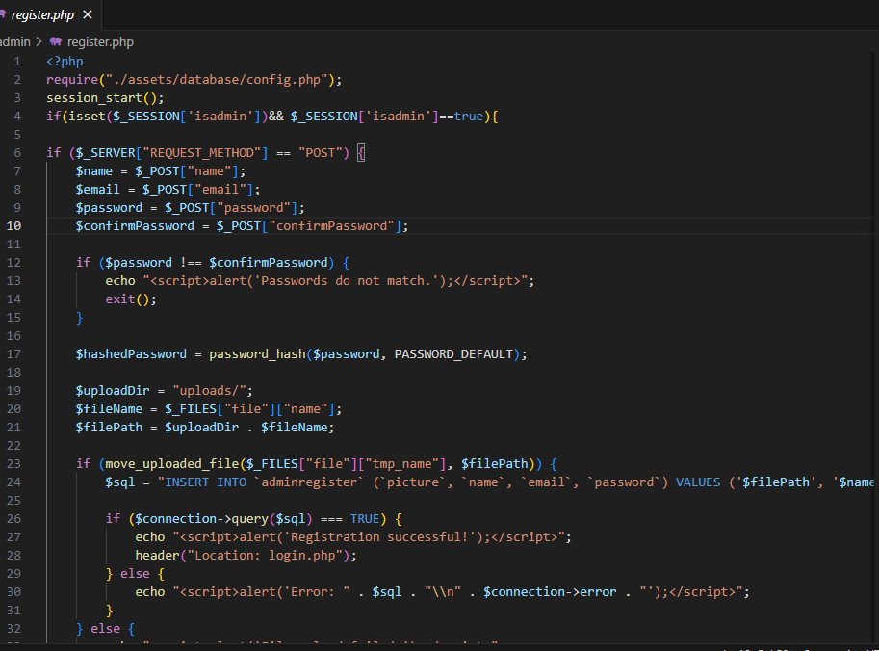

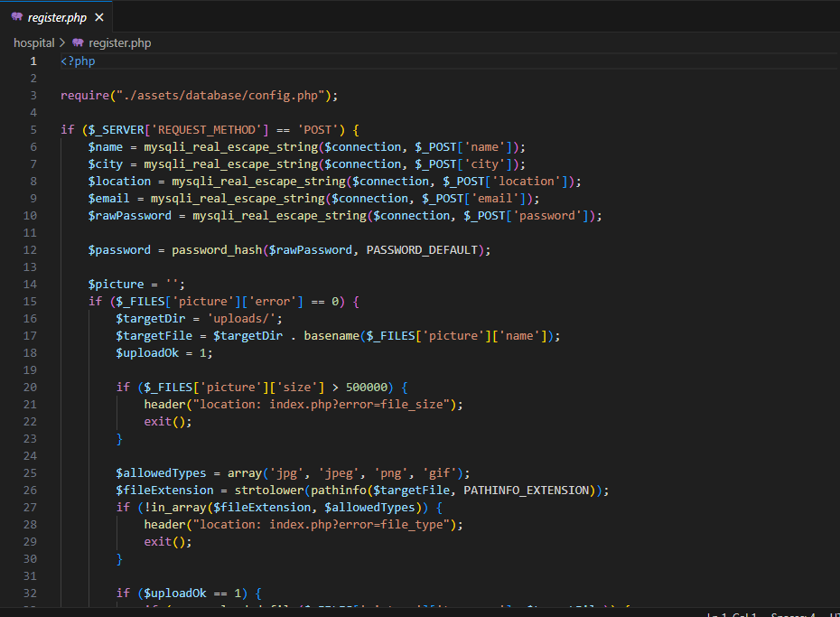

**LOGOUT**

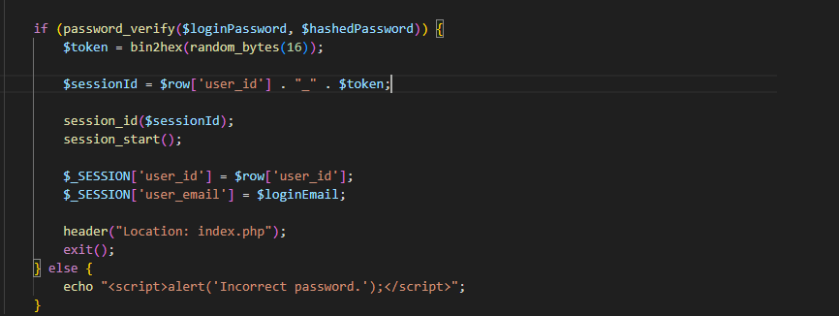**SESSION**

**ACCOUNT LOGIN**

**WITH**

**SESSION**

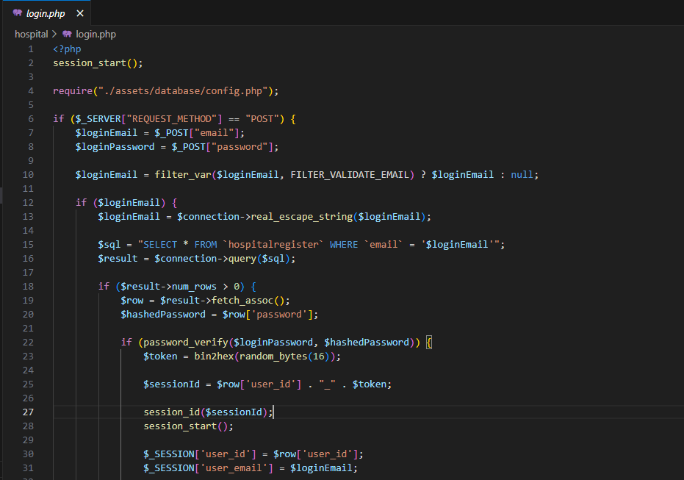

**LOG OUT**

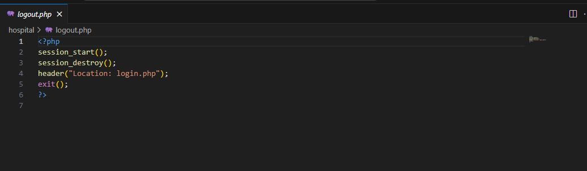

**DOWNLOAD REPORT**

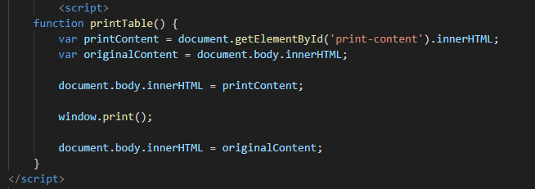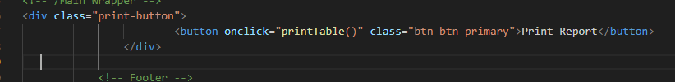

**CONTACT**

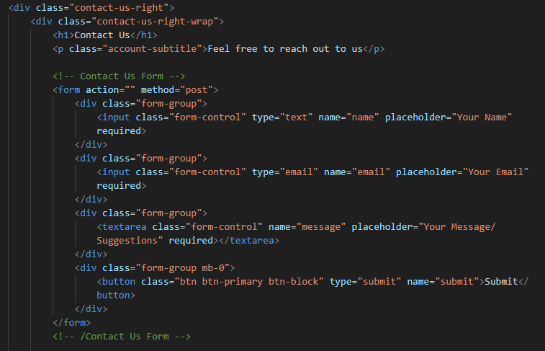

**HOSPITAL REGISTER**

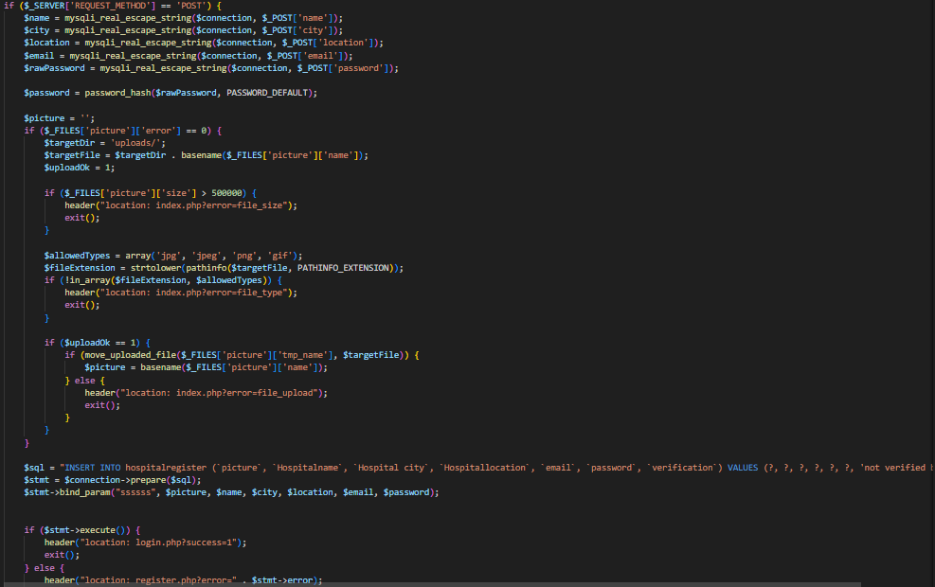

**HOSPITAL LOGIN**

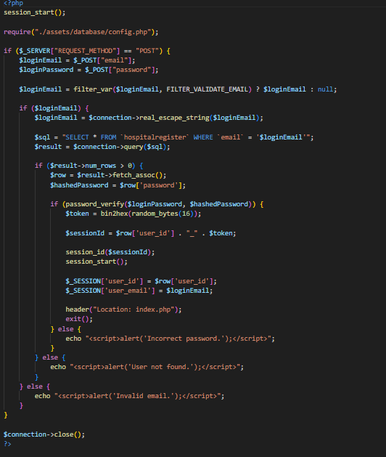

**DATABASE CONNECTION**

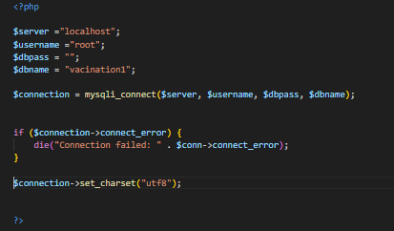

**VACCIATIO FORM SUBMIT**

<?php

require("./assets/database/config.php");

session_start();

if (isset( $_SESSION["user_id"] ))

{ $patientid=$_SESSION["user_id"];

    $pattientname=$_SESSION["user_name"];

if ($_SERVER['REQUEST_METHOD'] === 'POST') {

    $parentName = $_POST['parent_name'];

    $phoneNumber = $_POST['phone_number'];

    $parentEmail = $_POST['parent_email'];

    $childName = $_POST['child_name'];

    $dateOfBirth = $_POST['date_of_birth'];

    $vaccine = $_POST['vaccine'];

    $uploadsDirectory = 'uploads/';

    $childPicture = '';

    if (!empty($_FILES['child_picture']['name'])) {

        $targetFile = $uploadsDirectory . basename($_FILES['child_picture']['name']);

        $uploadSuccess = move_uploaded_file($_FILES['child_picture']['tmp_name'], $targetFile);

        if ($uploadSuccess) {

            $childPicture = $targetFile;

        } else {

            die('File upload failed');

        }

    }

    $preferredTime = $_POST['preferred_time'];

    $hospital = $_POST['hospital'];

    $status = 'pending';

    $query = "INSERT INTO `vaccination_appointments`(`parent_name`, `phone_number`, `parent_email`, `Child Name`, `date of birth`, `Vaccine`,  `preferred_time`, `hospital`, `status`, `patientid`) VALUES ('$parentName', '$phoneNumber', '$parentEmail', '$childName', '$dateOfBirth', '$vaccine', '$preferredTime', '$hospital', '$status', '$patientid')";

    if ($connection->query($query) === TRUE) {

        echo "Record inserted successfully";

        header('Location: index.php');

    } else {

        echo "Error: " . $query . "<br>" . $connection->error;

    }

    $connection->close();

}

**APPOINTMENT STATUSVIEW**

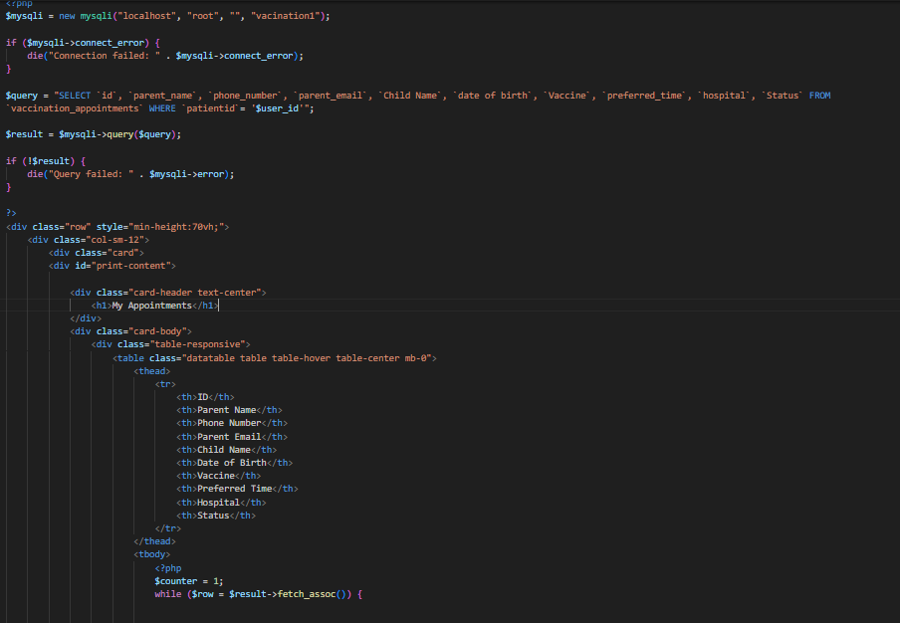

**SESSION**

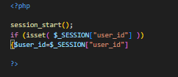

**APPOINTMENT STATUS**

**confirm/cancel/complete**

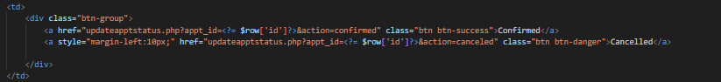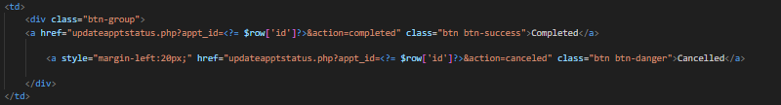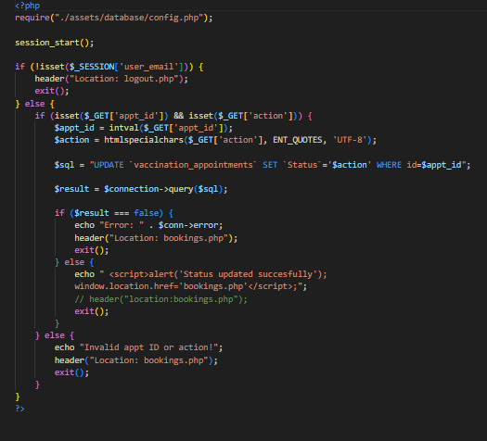

**APPROVE/DELETE /HOSPITAL**

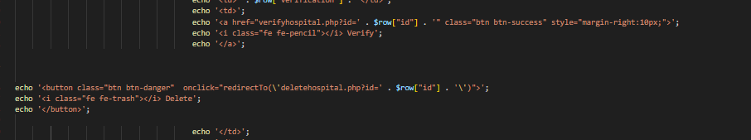

**VACCINE DATA FETCH**

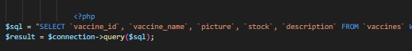

**PATIENT DATA FETCH**

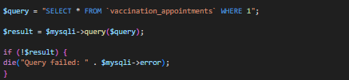

**DELETE HOSPITAL/VACCINE**



**HOSPITAL SESSION**

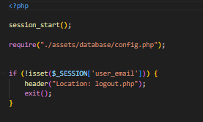

**HOSPITAL LOGOUT  
